SQL Queries for Product Analysis Project

- Create Database for Storing the Data set.
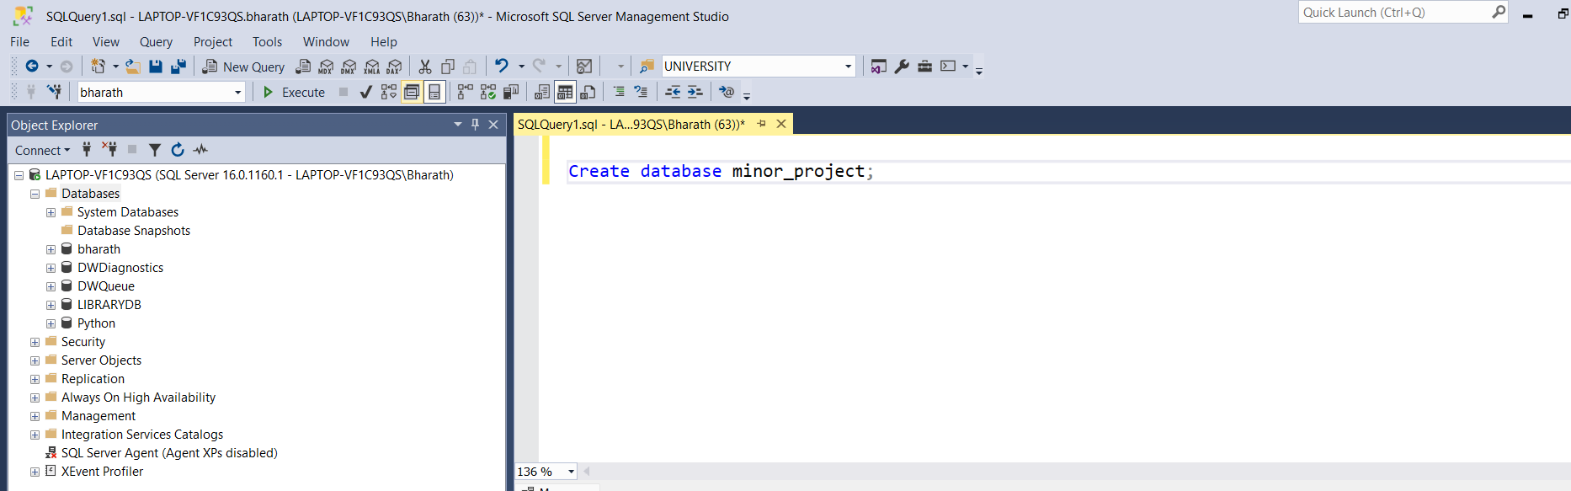

- Importing data into Excel sheet to SQL Server Management Studio.
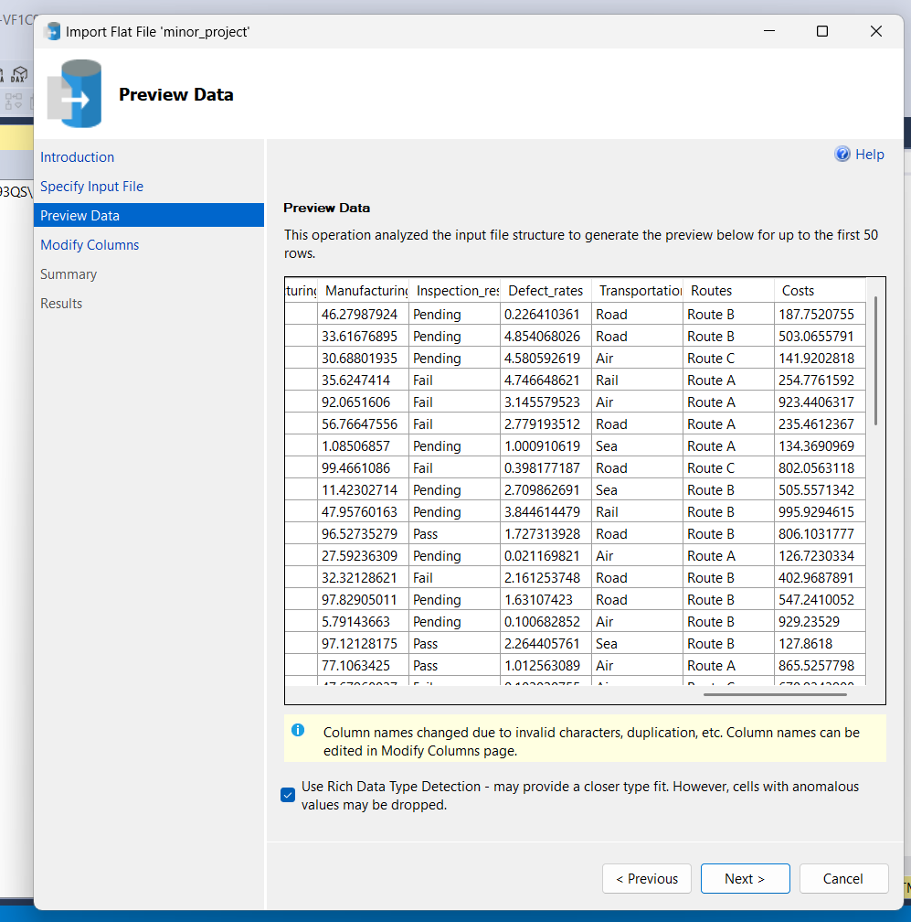

- Retrieve the data.

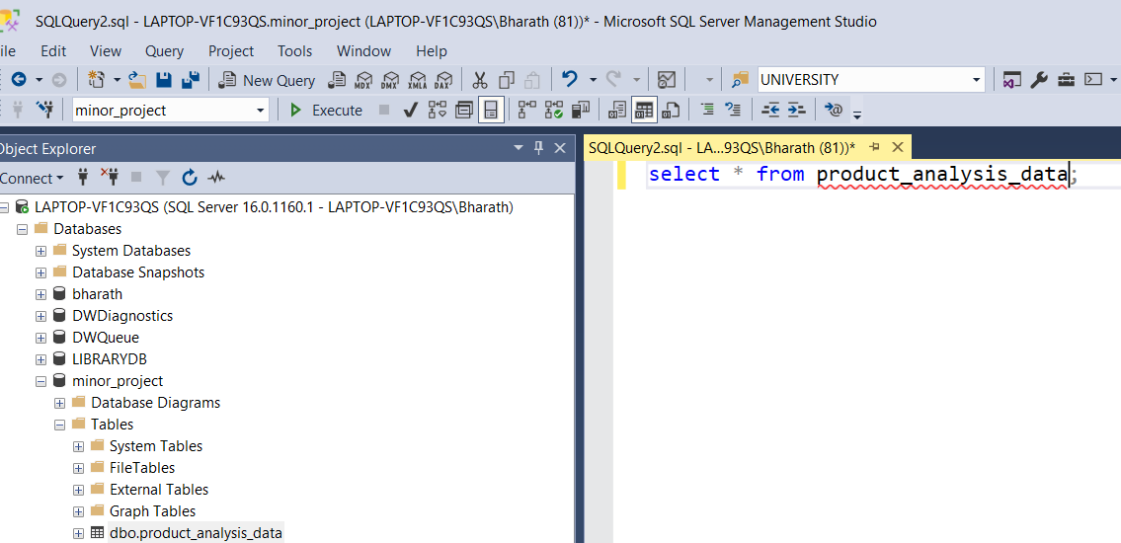
Output:
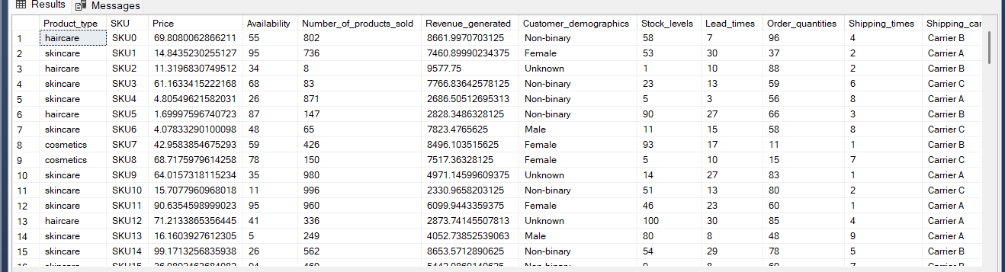

- Total Number of Products Sold for each product
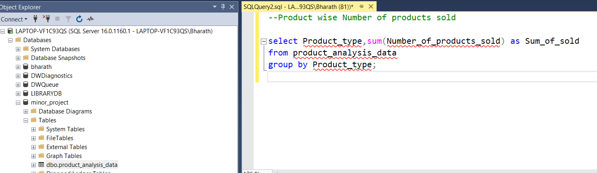
Output:
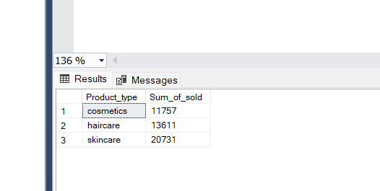

- Revenue Generated in Each Location
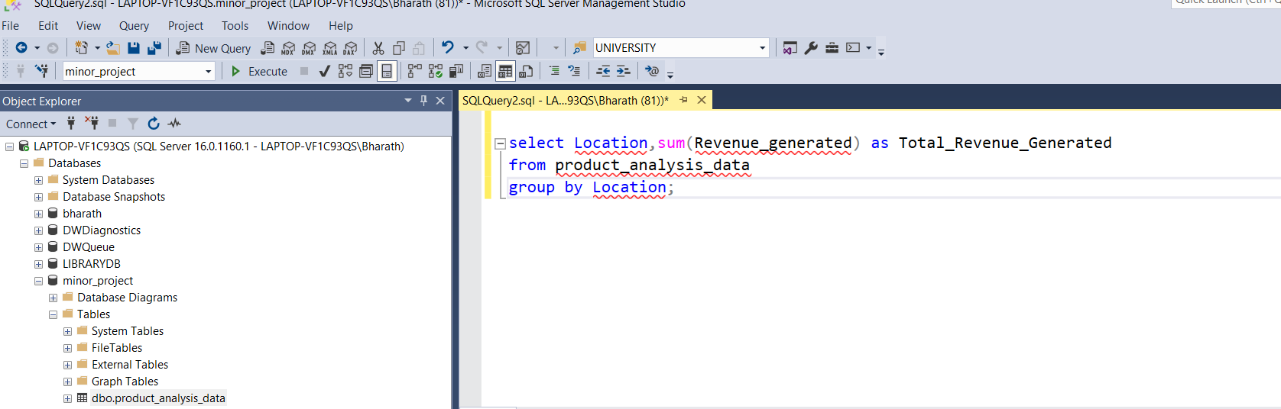
Output:
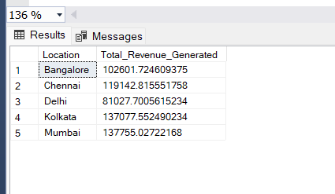

- Accessing Pending Inspection results

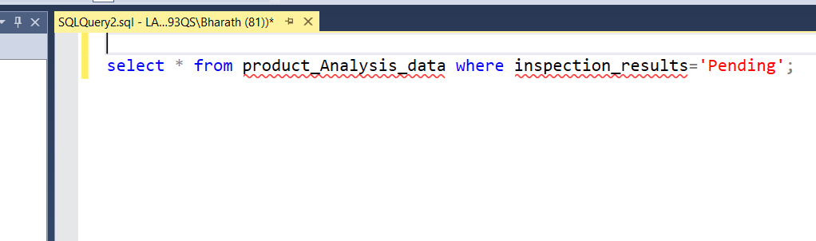
Output:
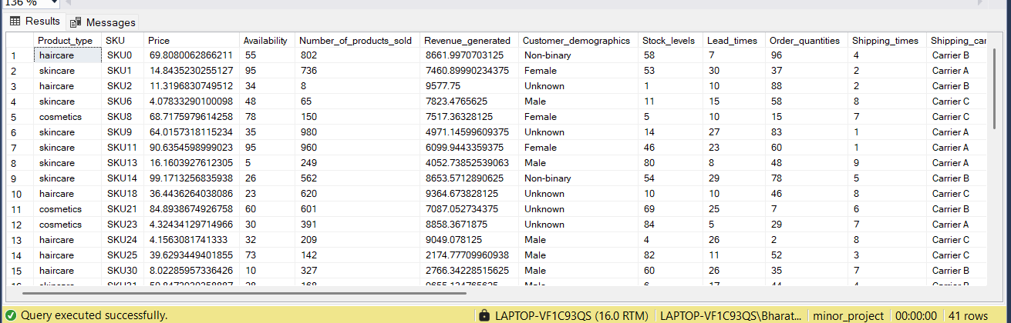

- Total costs for Each product type
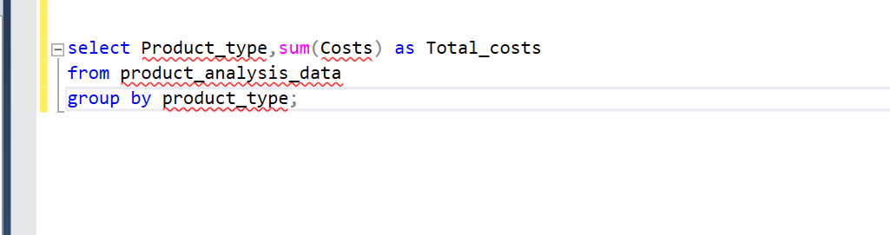
Output:
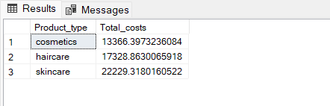

- Each Product Availability

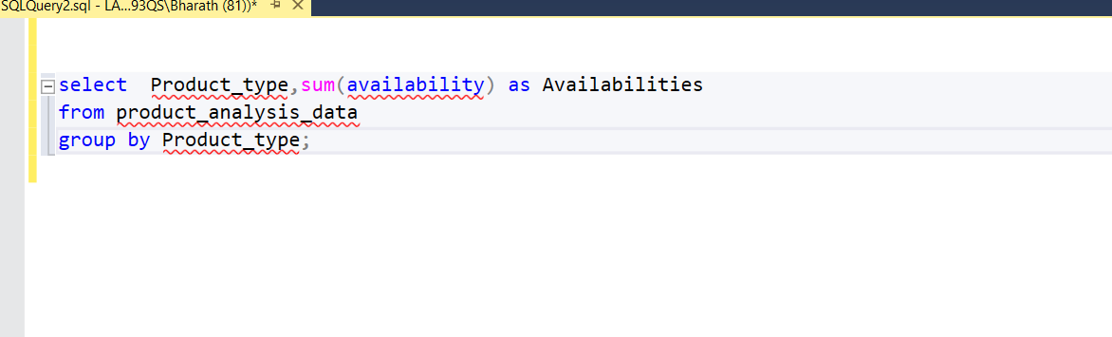
Output:
